H.T No
Regulations:
A20

Sreenidhi Institute of Science and Technology
(An Autonomous Institution)
Code No:8BC02 Date: 27-August-2024 (FN)

B.Tech I-Year II- Semester External Examination, August-2024 (Supplementary)
ENGINEERING GRAPHICS (CIVIL,ECE,CSE,CS,AIML,DS and IOT)

Time: 3 Hours Max.Marks:70

Note: a) No additional answer sheets will be provided.
b) All sub-parts of a question must be answered at one place only, otherwise it will not be valued.
c) Missing data can be assumed suitably.

Bloom's Cognitive Levels of Learning (BCLL)

Remember | L1 | Apply | L3 | Evaluate | L5
Understand | L2 | Analyze | L4 | Create | L6

Part - A Max.Marks:20
Answer all QUESTIONS

 |  | BCLL | CO(s) | Marks
1 | What are the requirements for constructions of scale? | L2 | CO1 | [2M]
2 | What is the difference between true inclination of a line and apparent angles? | L2 | CO2 | [2M]
3 | What is the difference between regular and irregular polygons? | L2 | CO3 | [2M]
4 | How Do You Create Sectional Views? | L2 | CO4 | [2M]
5 | Define isometric views? | L1 | CO5 | [2M]
6 | Define offset method? | L1 | CO6 | [2M]
7 | What do you understand by the term notation of dimensioning? | L2 | CO1 | [2M]
8 | What Is Difference Between A Plane And A Lamina? | L2 | CO3 | [2M]
9 | What are the uses of Isometric Sketch? | L2 | CO5 | [2M]
10 | Differentiate between first angle and third angle projections? | L3 | CO2 | [2M]
Part – B Max.Marks:50
ANSWER ANY FIVE QUESTIONS. EACH QUESTION CARRIES 10 MARKS.

 |  |  | BCLL | CO(s) | Marks
11. |  | A fixed point is 75mm from a fixed straight line. Draw the locus of a point P moving in such way that its distance from the fixed straight line is equal to it distance from the fixed point. Name the curve. Draw a normal and tangent on the curve. | L3 | CO1 | [10M]
12. |  | The top view of a 75mm long line AB measures 65mm, while the length of its front view is 50mm. Its one end A is in the HP and 12mm in front of the VP. Draw the projections of AB and determine its inclination with the HP and the VP | L3 | CO2 | [10M]
13. |  | A pentagonal pyramid base 25mm side and axis 75mm long has one of its triangular faces in the VP and the edge of the base contained by that face makes an angle of 30⁰ with the HP Draw its projections. | L3 | CO3 | [10M]
14. |  | A cone of base 55mm diameter and axis 65mm long, rests with base on H.P. A section plane perpendicular to both H.P and V.P cuts the cone at a distance of 8mm from the axis .draw the top view, front view and sectional side view. | L4 | CO4 | [10M]
15. |  | A square pyramid of side 30mm, axis length 50mm is centrally placed on top of a cube of side 50mm. Draw the isometric projections of solids. | L3 | CO5 | [10M]
16. |  | Draw the elevation, plan and left and right views of the bracket shown in the figure  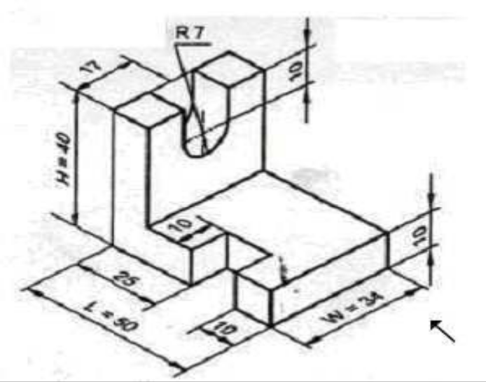 | L3 | CO6 | [10M]
17. |  | Draw the projection of a circle of 60mm diameter resting on the V.P. on a point on the circumference. The plane is inclined at 45⁰ to V.P. and perpendicular to the H.P. The center of the plane is 40mm above H.P | L4 | CO1 | [10M]
18. |  | What are the different types of AutoCAD objects? How can you modify the properties of an object in AutoCAD? | L2 | CO4 | [10M]
-- 00 -- 00 –

